Follow these steps to set up the software and hardware for the VeriStand hands on demo. At the end, we will verify the proper configuration before handing the equipment (minus your windows computer) to the customer.

Equipment needed:

* PXI RT Controller with at least 256mb of RAM.
* PXI R Series, either 7811R, 7831R, 7833R, 7852R or 7854R.
  + If you cannot get one of these cards, you can use the FPGA source to build for a different target. Contact Stephen Barrett for details
* sbRIO 9631
  + If you cannot get one of these cards, you can use the source to build for a different target. Contact Stephen Barrett for details
* SH68-C68-S cable
* 68M-50F adaptor

Step by step instructions to set up the PXI RT target, sbRIO, and host computer **if you’re not using the ones provided**:

1. Install LabVIEW and the CD & Sim module to your Windows computer.
2. Install NI VeriStand to your Windows computer.
3. Install the drivers mentioned required on the NIVS readme
4. Install NI VeriStand to the PXI RT Target (must have at least 128mb of RAM)
   1. Open MAX, find the RT target, expand it, right click software -> add remove programs
   2. Select NI VeriStand RT engine and select install this feature
   3. Select CD & Sim and select install this feature
5. Run the NI VeriStand Hands On installer **for your operating system**
   * This will place all the hands on files on your computer in the appropriate directories.
   * A shortcut to the hands on doc will be placed on the desktop.
6. Plug in the sbRIO power and connect Port 1 of the R Series card to the bottom left digital connector of the sbRIO, as shown:  
   **\*DO NOT PLUG INTO ANY OTHER THAN THE ONE SHOWN IN THE PICTURE, YOU WILL DAMAGE YOUR R SERIES CARD\***

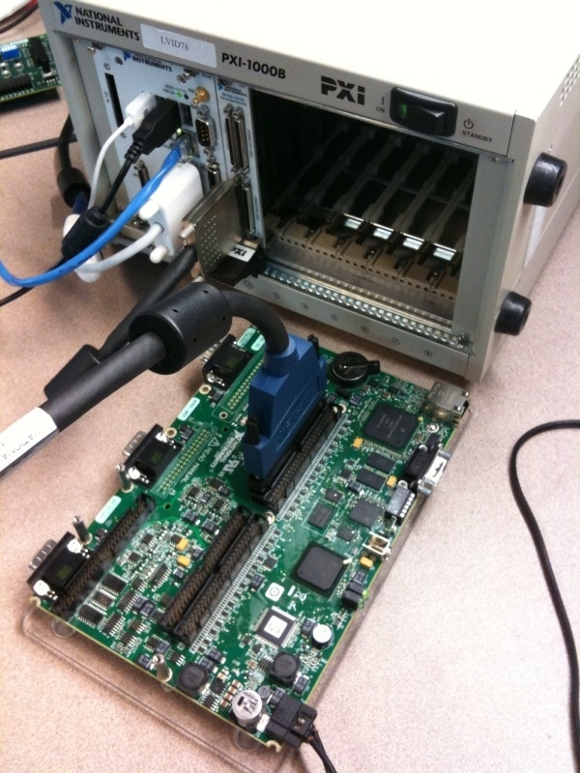

1. The sbRIO should already have an image running on it of the controller code. If you are using your own sbRIO (not one we provide), you should use the sbRIO imager tool to image it (see Source\sbRIO Controller\System Replication). You will know it is running the proper code when the LED blinks.

Verify proper functionality.

1. Open NI VeriStand. Close and reopen it if you had it open.
2. Open Phase III solution.
3. Change the IP address of the RT target to match yours. (Configure project -> Double click system definition -> controller settings)
4. Right click the project and select run.
5. Move the elevation and travel controls and note the 3d picture controls response.

**If this does not work**, contact Stephen Barrett.

Give the customer the hardware and the customer setup doc to have them setup their own windows machine with this hardware.